Module 2: Library Management System

**1. Branch**

* **Branch_no - Set as PRIMARY KEY**
* **Manager_Id**
* **Branch_address**
* **Contact_no**

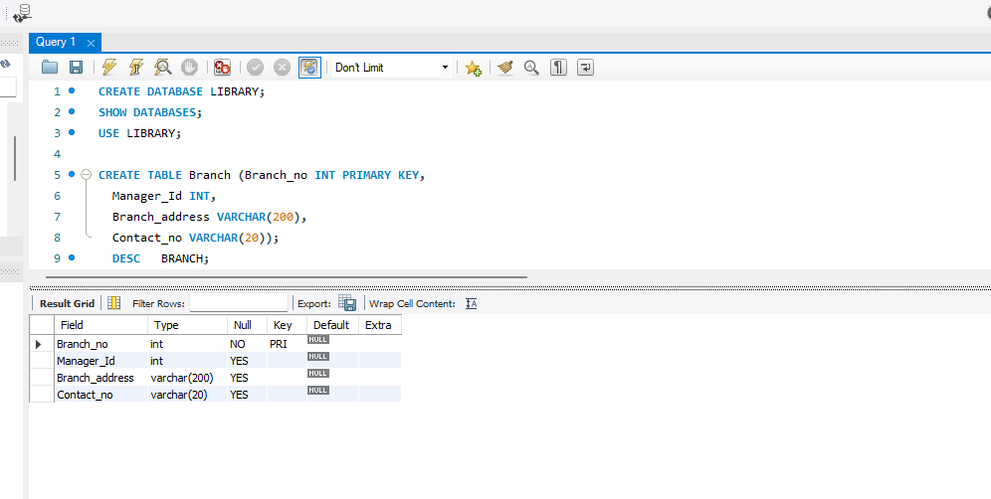

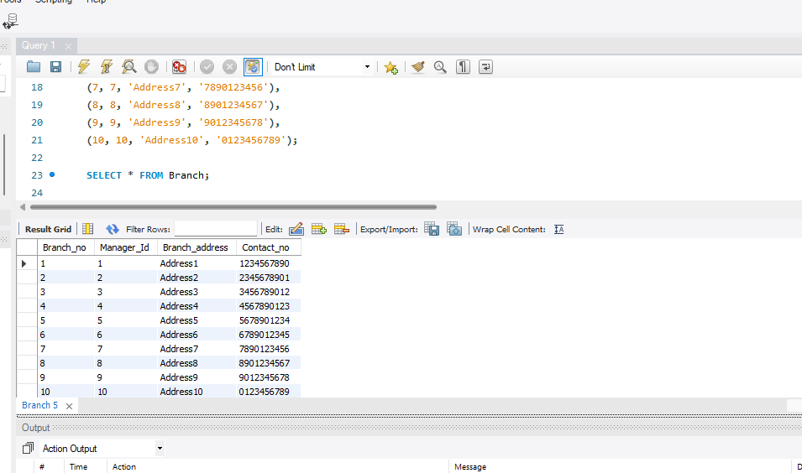

**2. Employee**

**Emp_Id – Set as PRIMARY KEY**

**Emp_name**

**Position**

**Salary**

**Branch_no - Set as FOREIGN KEY and it refer Branch_no in Branch table**

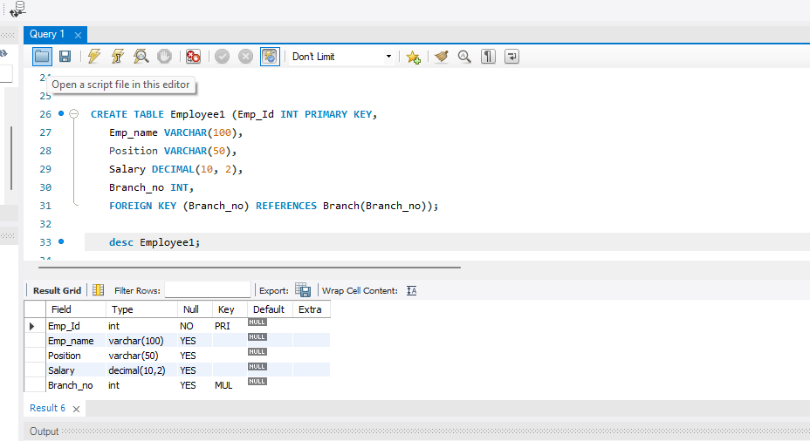

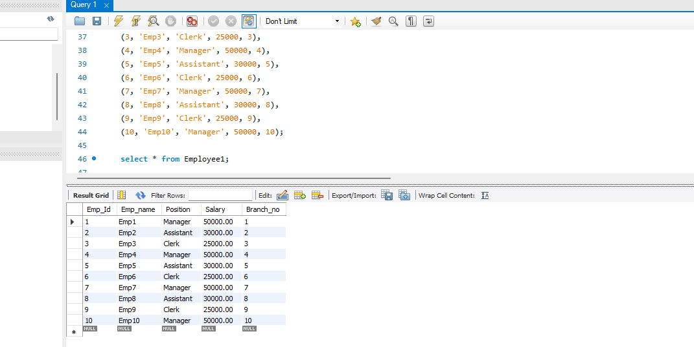

**3. Books**

**ISBN - Set as PRIMARY KEY**

**Book_title**

**Category**

**Rental_Price**

**Status [Give yes if book available and no if book not availab**le]

* **Author**
* **Publisher**

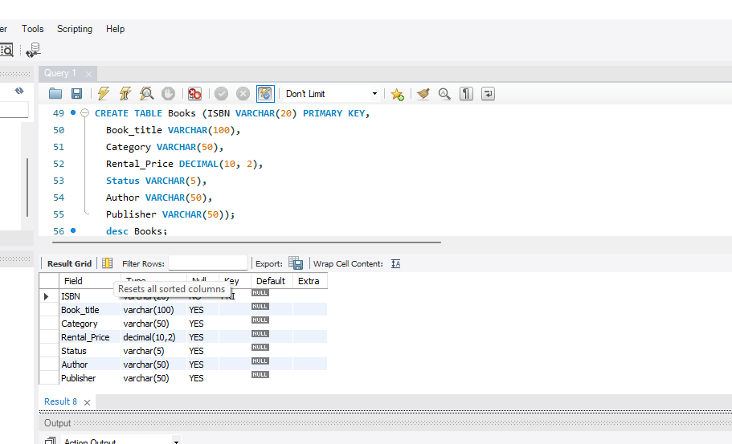

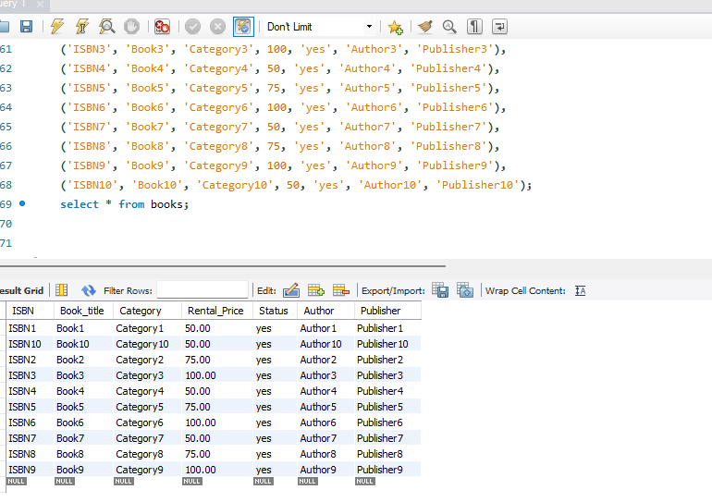

**4. Customer**

* **Customer_Id - Set as PRIMARY KEY**
* **Customer_name**
* **Customer_address**
* **Reg_date**

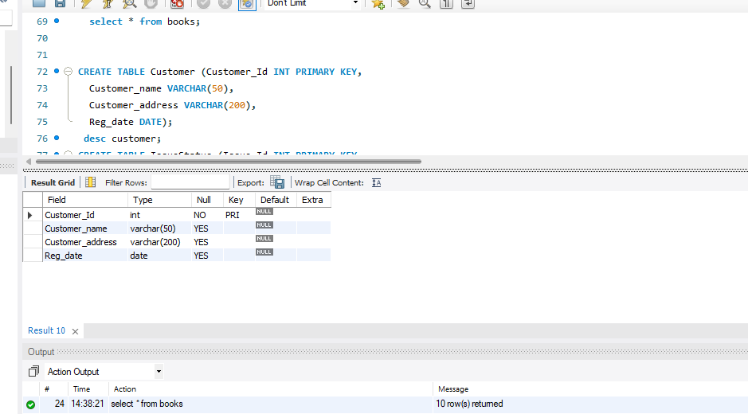

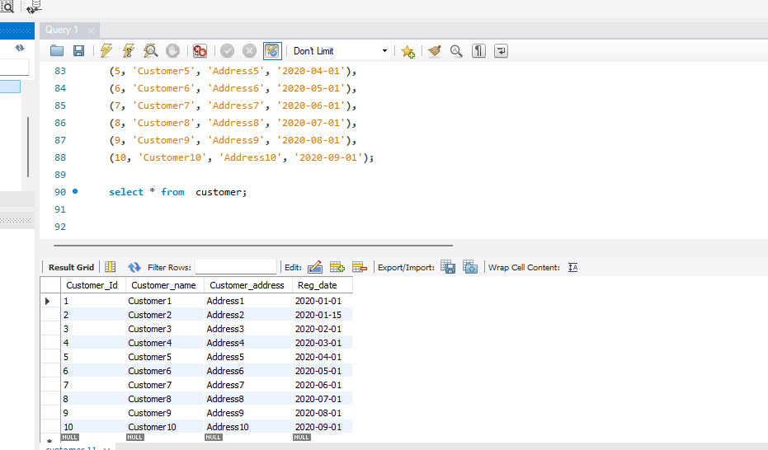

5**. IssueStatus**

* **Issue_Id - Set as PRIMARY KEY**
* **Issued_cust – Set as FOREIGN KEY and it refer customer_id in CUSTOMER table  Issued_book_name**
* **Issue_date**
* **Isbn_book – Set as FOREIGN KEY and it should refer isbn in BOOKS table**

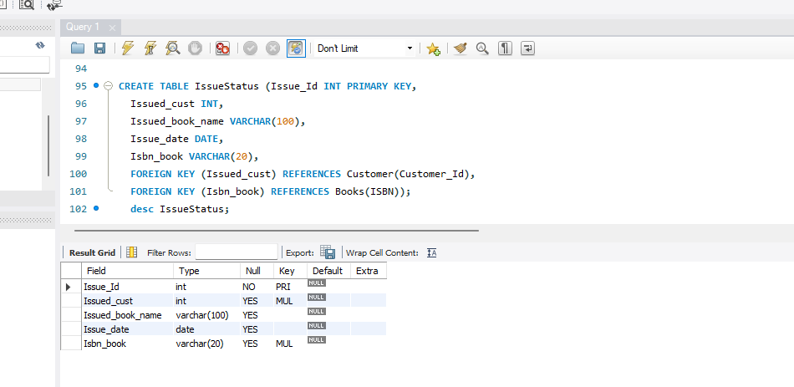

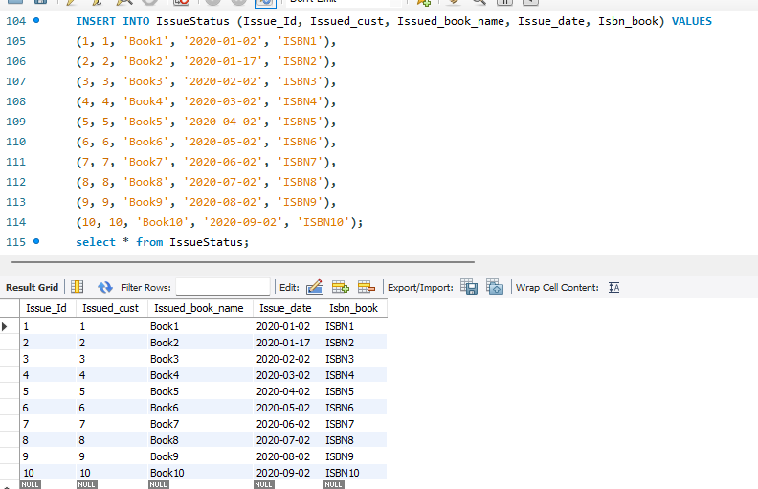

**6. ReturnStatus**

* **Return_Id - Set as PRIMARY KEY**
* **Return_cust**
* **Return_book_name**
* **Return_date**
* **Isbn_book2 - Set as FOREIGN KEY and it should refer isbn in BOOKS table**

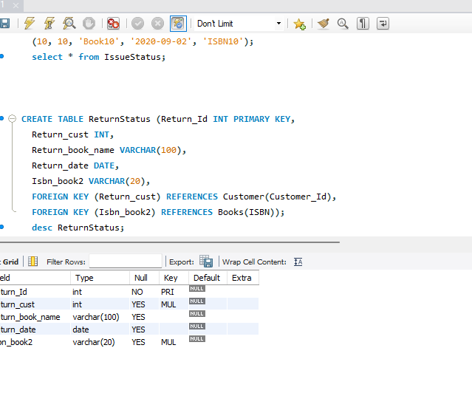

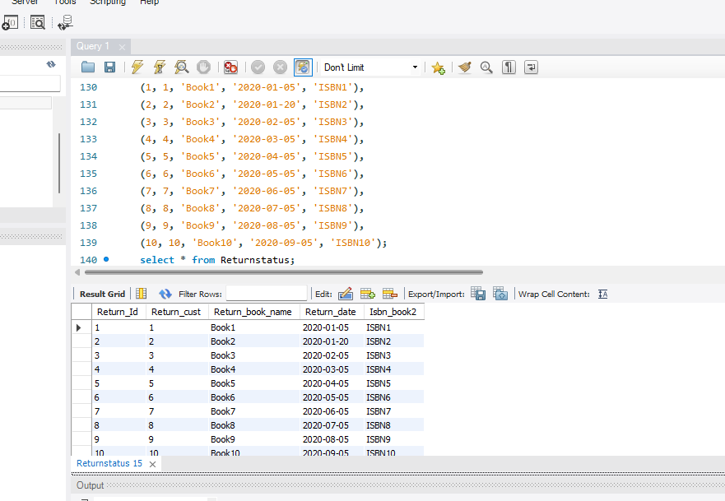

**Display all the tables and Write the queries for the following :  
  
1. Retrieve the book title, category, and rental price of all available books.**

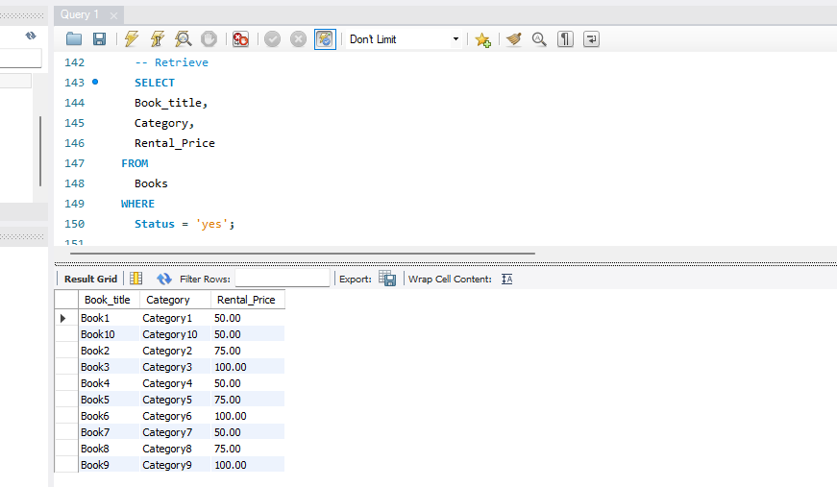

**2. List the employee names and their respective salaries in descending order of** salary.

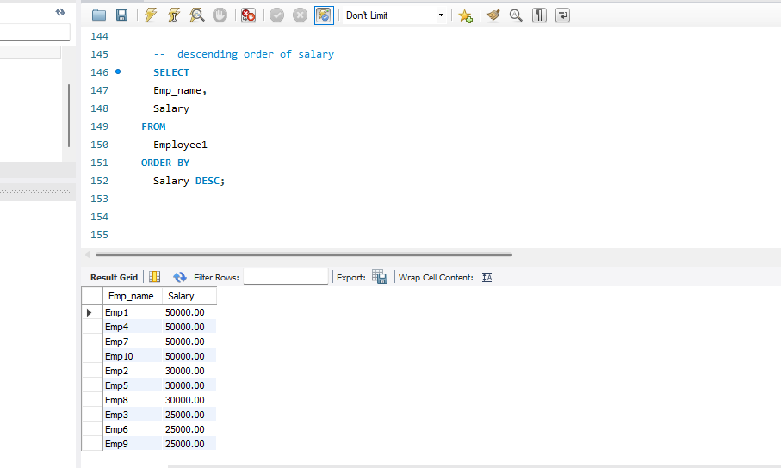

3**. Retrieve the book titles and the corresponding customers who have issued those books.**

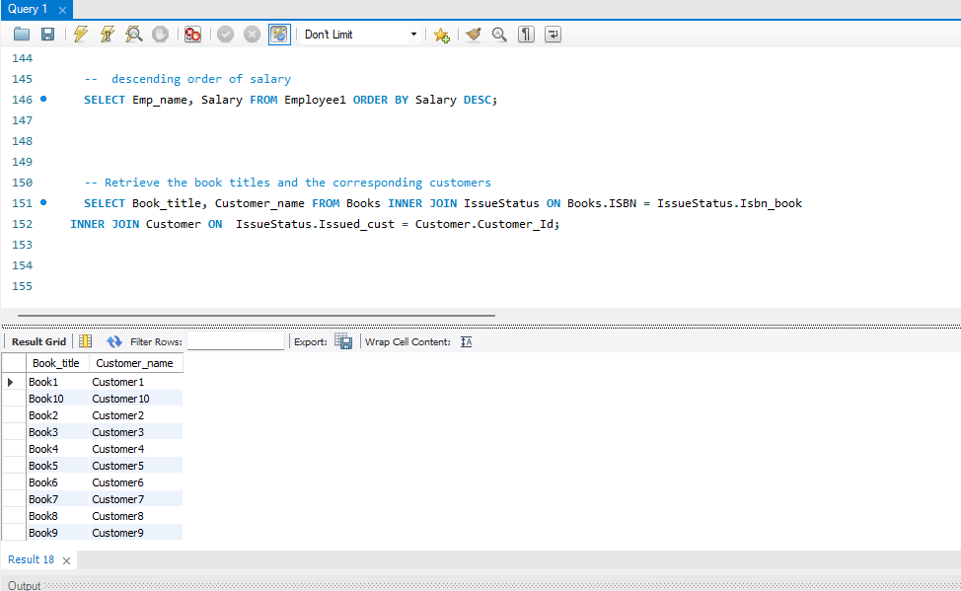

4**. Display the total count of books in each category.**

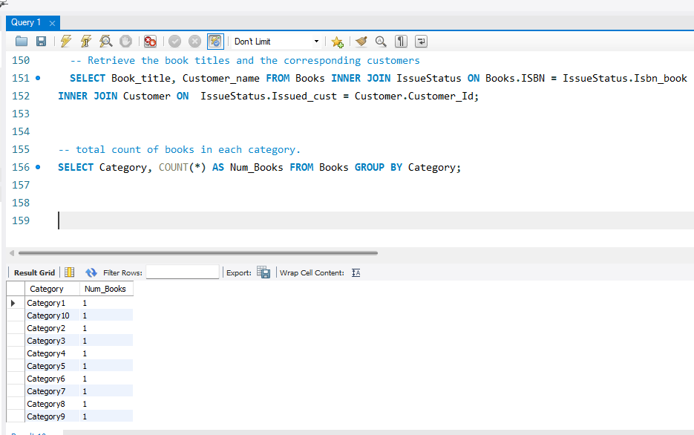

5**. Retrieve the employee names and their positions for the employees whose salaries are above Rs.25,000.**

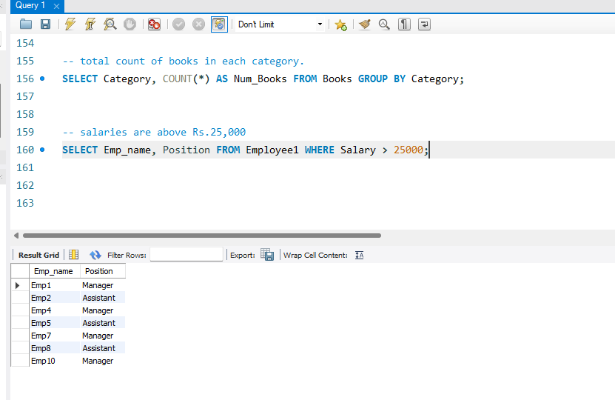

**6. List the customer names who registered before 2022-01-01 and have not issued any books yet.**

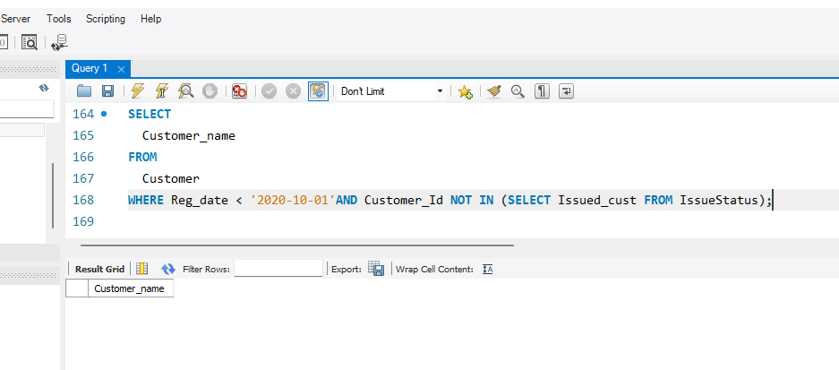

**7. Display the branch numbers and the total count of employees in each branch.**

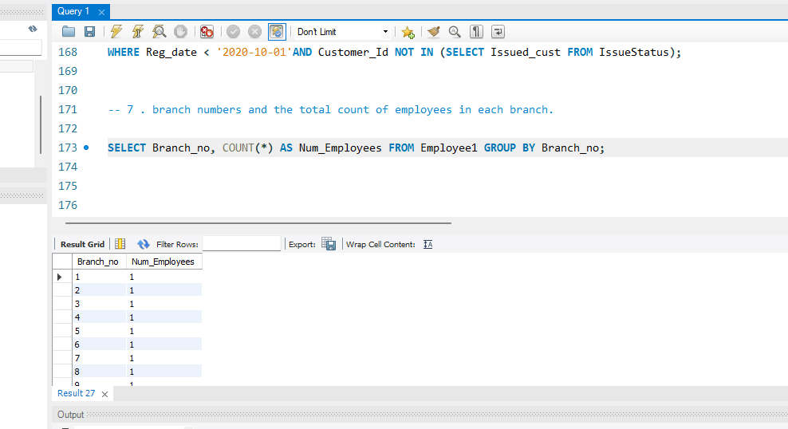

**8. Display the names of customers who have issued books in the month of June 2023.**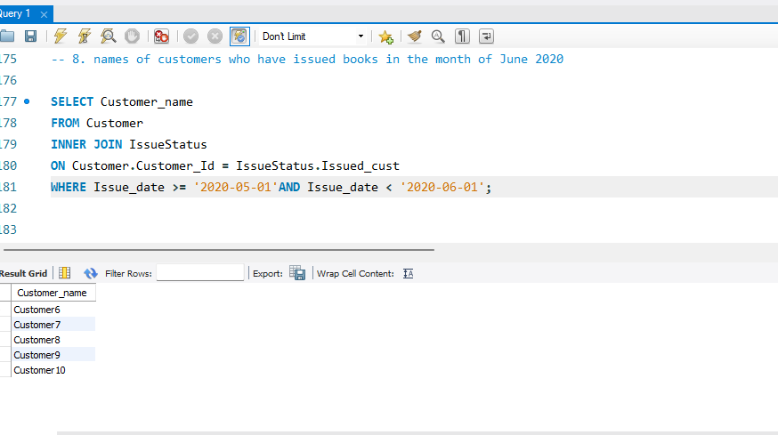

**9. Retrieve book_title from book table containing history.**

**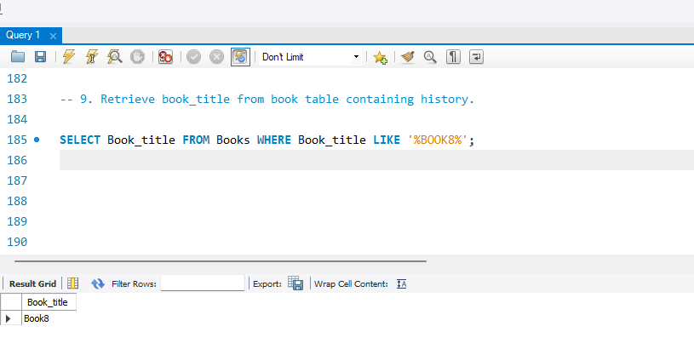  
10.Retrieve the branch numbers along with the count of employees for branches having more than 5 employees**

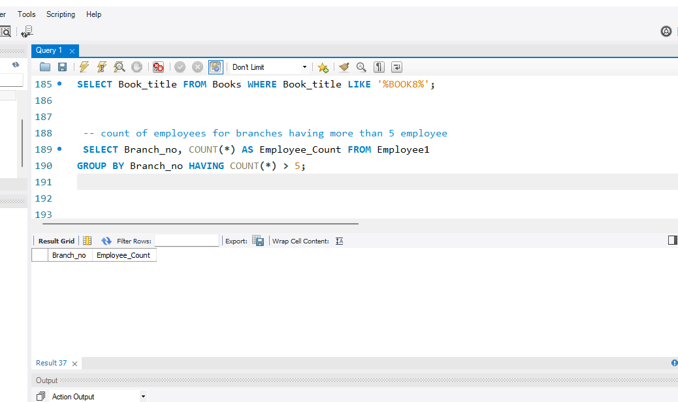

**11. Retrieve the names of employees who manage branches and their respective branch addresses.**

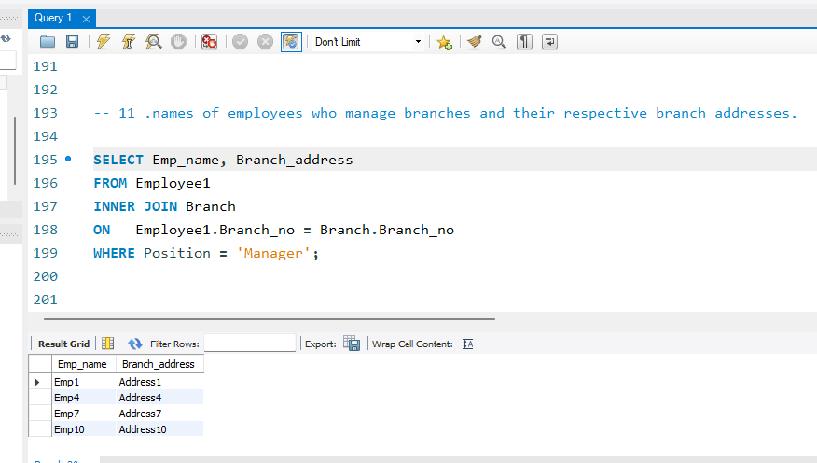

**12.  Display the names of customers who have issued books with a rental price higher than Rs. 25.**